Abstract guidelines for EUROMECH Colloquium 656: Title

First Author¹, Second Author², Third Author^{3,*}
¹ Affiliation 1
² Affiliation 2
³ Affiliation 3

Introduction
Please submit a maximum two-page abstract. Please use the font sizes specified in this template for each section.

Sections
You can have sections in your abstract. Please don’t number your sections and use the font size and style specified in this template.

Subsection
If you’d like to have subsections, use italic form for it. Please don’t number them.

Equations
All equations should be inserted centerline and numbered as follows:
$A= \int_{a}^{b}{f\left(x\right)dx}$. (1)

Figures
Please include your figures centerline. You can have sub-figures if you’d like to. Captions should be included below figures.
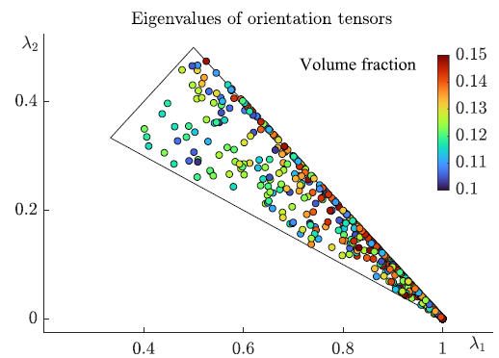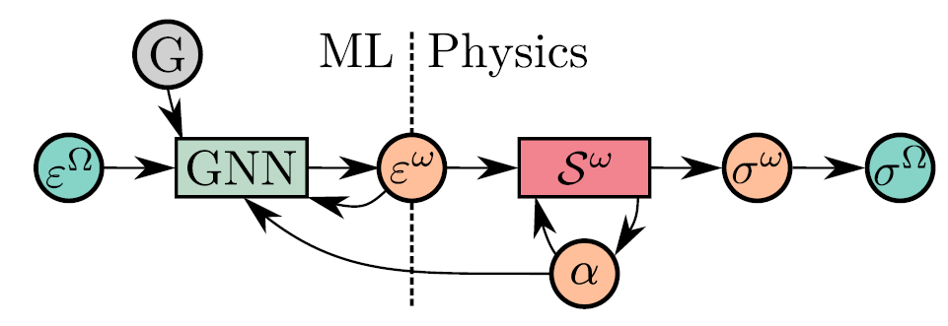
(b)
(a)

Figure 1: (a) Eigenvalues of randomly generated diagonal orientation tensors (taken from [1]), (b) Abstract overview of the multi-step GNN predictions (taken from [2]).

Tables

Table 1: Table captions should be above tables and centerline.
a | b | c | d | e
1 | 2 | 3 | 4 | 5
6 | 7 | 8 | 9 | 10
*Corresponding author: Email address of the corresponding author

Abstract submission
Please check the conference website for instructions.

Important dates
Abstract submission opens: September 15, 2024
Deadline for abstract submission: January 15, 2025
Notification of abstract acceptance: February 10, 2025
Early bird registration: March 1, 2025
Late registration: March 30, 2025

How to format references
Please include your references in the reference list in the order they are cited in the document. Examples of journal articles [1,2] and books [3] are given below. Please follow these formatting guidelines.

References
- H.L. Cheung, P. Uvdal, M. Mirkhalaf, (2024). Augmentation of scarce data - a new approach for deep-learning modelling of composites. Composites Science and Technology 249, 110491.
- J. Storm, I.B.C.M. Rocha, F.P. van der Meer, (2024). A microstructure-based graph neural network for accelerating multiscale simulations, Computer Methods in Applied Mechanics and Engineering 427, 117001.
- B. Mehlig. Machine Learning with Neural Networks: An Introduction for Scientists and Engineers. Cambridge University Press, 2021.

